

3 Uses of Chatbot

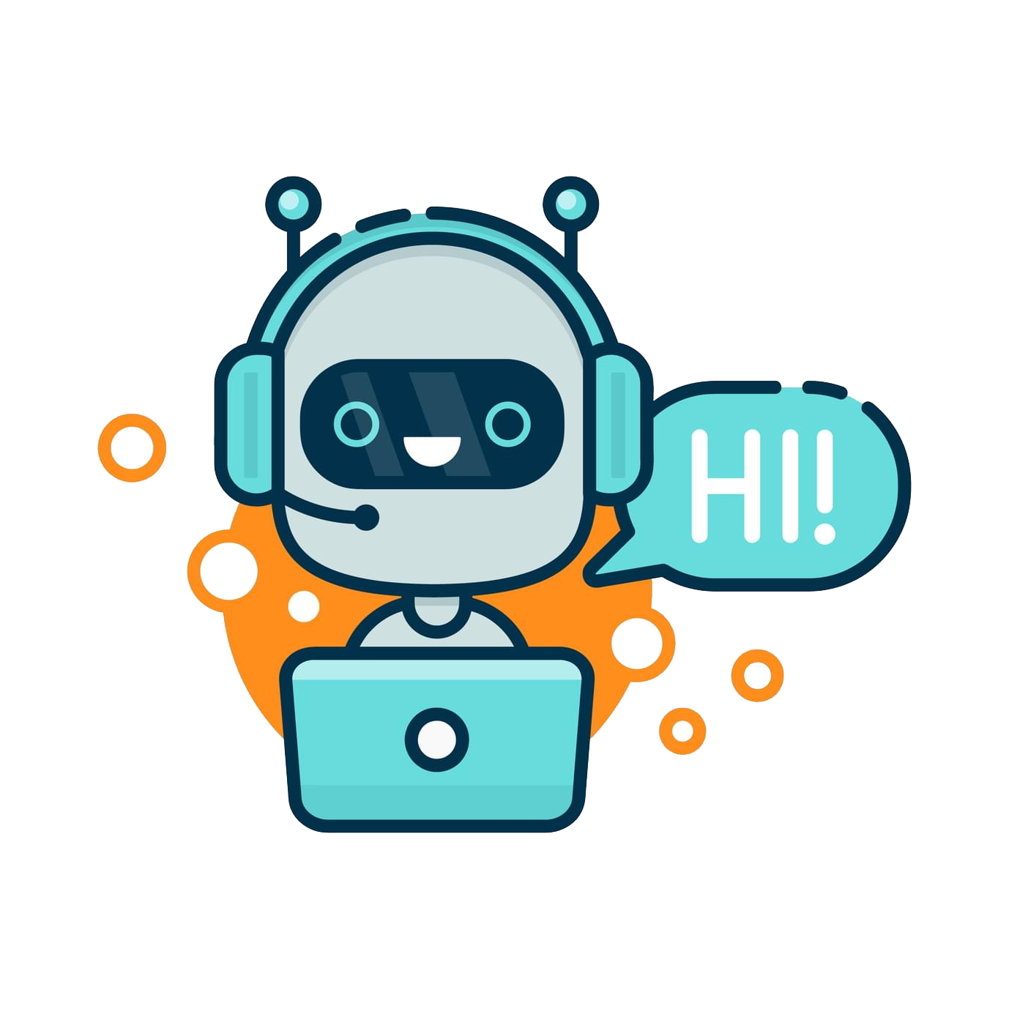

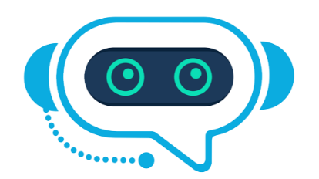

By- Shivam Kumar Giri
3 USECASES OF CHATBOT

CHAT BOT IN BUSINESS AUTOMATION

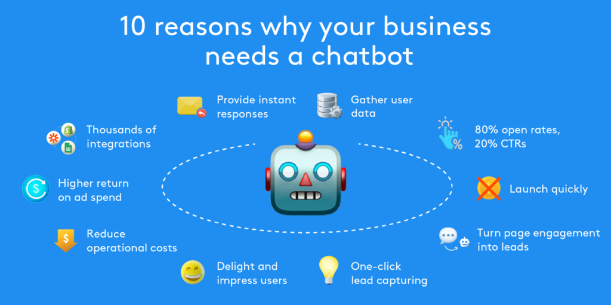

People tend to be less productive when given a recurring job or work. We humans usually get bored doing the same thing over and over again. Chatbots can now automate tasks which are to be done frequently and at the right time. And now there are already numerous slack bots which automate repetitive tasks. This helps people save time and be more productive.
Many high-tech banking organizations are looking to integrate automated AI-based solutions such as chatbots into their customer service in order to provide faster and cheaper assistance to their clients who are becoming increasingly comfortable with technology. In particular, chatbots can efficiently conduct a dialogue, usually replacing other communication tools such as email, phone, or SMS. In banking, their major application is related to quick customer service answering common requests, as well as transactional support.
Several studies report significant reduction in the cost of customer services, expected to lead to billions of dollars of economic savings in the next 10 years. In 2019, Gartner predicted that by 2021, 15% of all customer service interactions globally will be handled completely by AI. A study by Juniper Research in 2019 estimates retail sales resulting from chatbot-based interactions will reach $112 billion by 2023. Since 2016 when Facebook allowed businesses to deliver automated customer support, e-commerce guidance, content and interactive experiences through chatbots, a large variety of chatbots were developed for the Facebook Messenger platform. Major Benefits of chatbot in business automation are:
- 24X7 Service Available
- Assistance or access to information quickly and efficiently.
- Chatbots fuel conversions and enhance user experiences.
- Much greater user handling t a particular instance.

PERSONALIZE ASSISTANCE
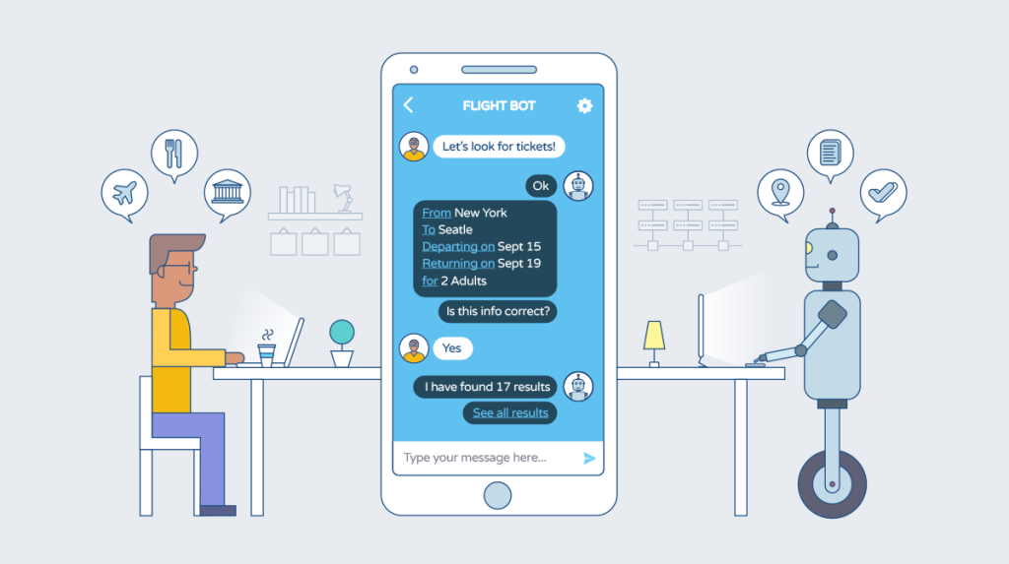
Following are the uses of chatbots in personal use cases:
- Control your devices and your smart home
- Access information from your calendars and other personal information
- Find information online, from restaurant bookings to directions, weather and news
- Control your music
- Run timers and reminders
- Make appointments and send messages
- Open apps on your phone
- Read your notifications to you
- Real-time spoken translations
- Book tickets for movies, flight train etc.
- Access to data over Internet.
- 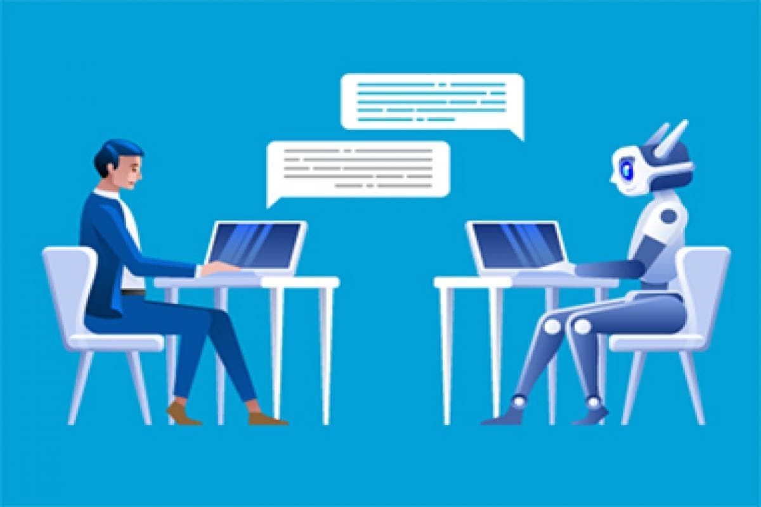

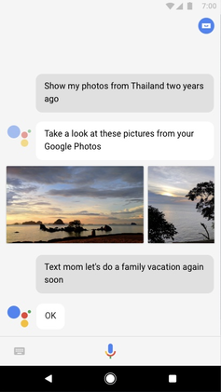
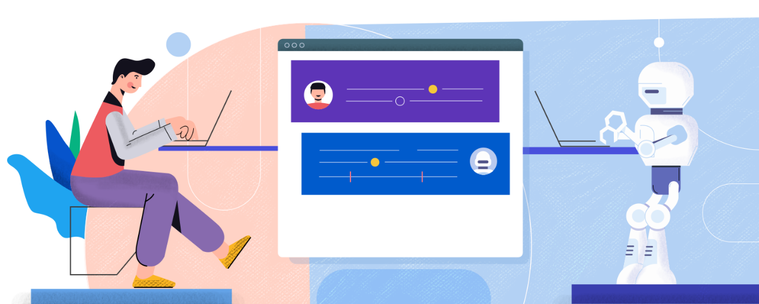
Google Assistant is an artificial intelligence–powered virtual assistant developed by Google that is primarily available on mobile and smart home devices. Unlike the company's previous virtual assistant, Google The Google Assistant can also engage in two-way conversations.

CHATBOT IN HEALTH CARE

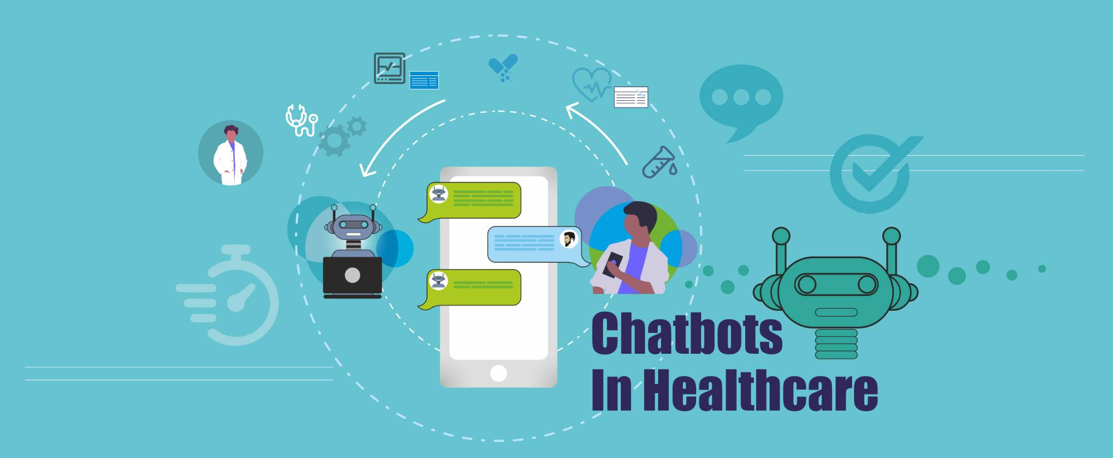
Chatbots are also appearing in the healthcare industry. A study suggested that physicians in the Healthcare sectors believed that chatbots would be most beneficial for scheduling doctor appointments, locating health clinics, or providing medication information.

Certain patient groups are still reluctant to use chatbots. A mixed-methods study showed that people are still hesitant to use chatbots for their healthcare due to poor understanding of the technological complexity, the lack of empathy and concerns about cyber-security. The analysis showed that while 6% had heard of a health chatbot and 3% had experience of using it, 67% perceived themselves as likely to use one within 12 months. The majority of participants would use a health chatbot for seeking general health information (78%), booking a medical appointment (78%) and looking for local health services (80%).
While 80% were curious about new technologies that could improve their health, 66% reported only seeking a doctor when experiencing a health problem and 65% thought that a chatbot was a good idea. During the COVID-19 pandemic, many chatbots were deployed to provide information to end users.
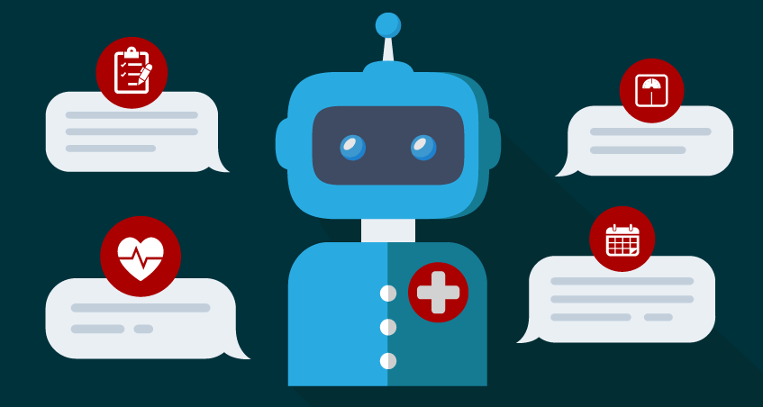

CONCLUSION

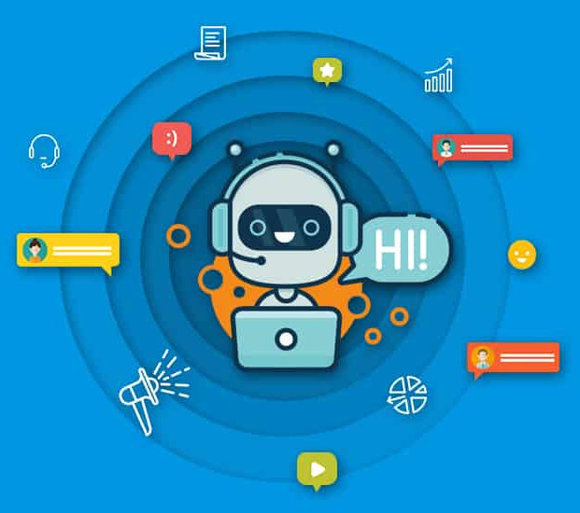
Chatbots have a wide array of applications, even more than the above mentioned few of them. Since data shows that more and more people are more comfortable to chat rather than call there will be a demand for use of chatbots by several industries. The reason for such exploding popularity is the rise of mobile messengers and extension technology of artificial intelligence. It would gravely improve their revenues and customer satisfaction. With technology moving faster than ever before, it has become very easy to create a chatbot with so many platforms out there.

THE END

